# Task 1: My learning

**1, Mind map of “Level of words”**

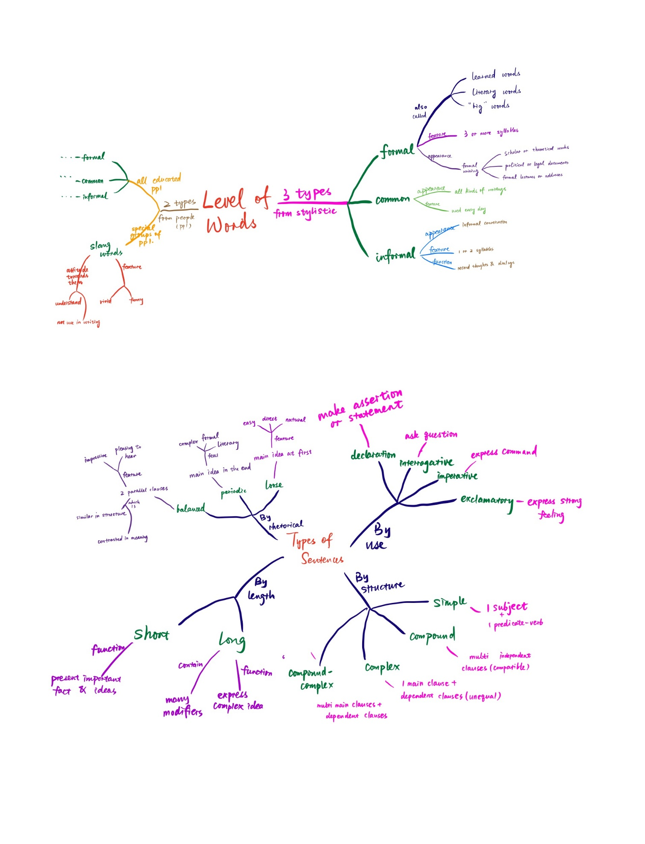

**2, Mind map of “Types of sentences”**

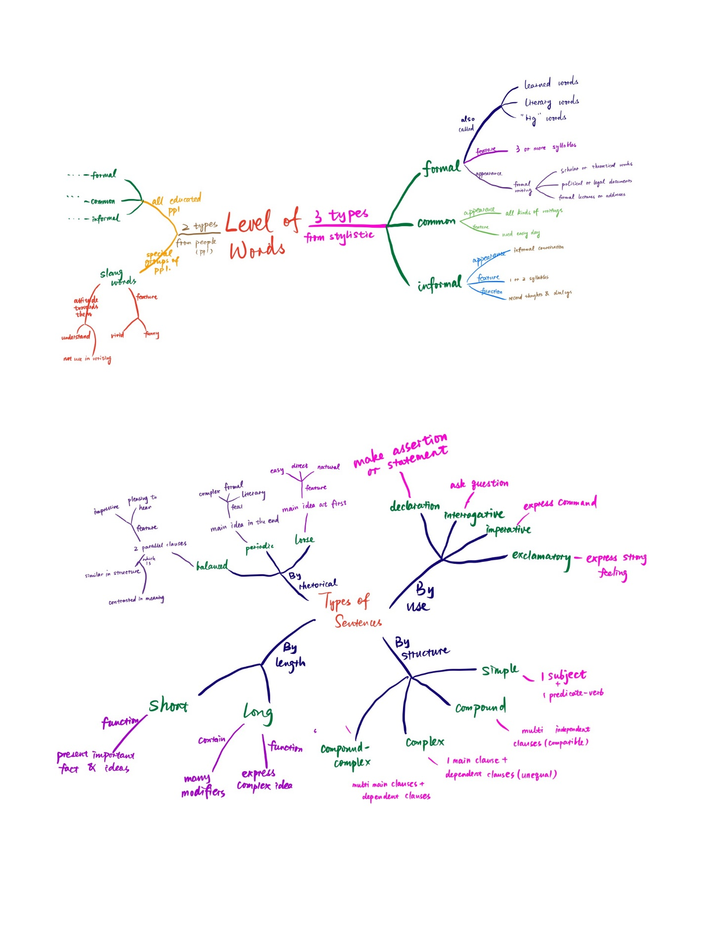

**3, Mind map of “Criteria of effective paragraph”**

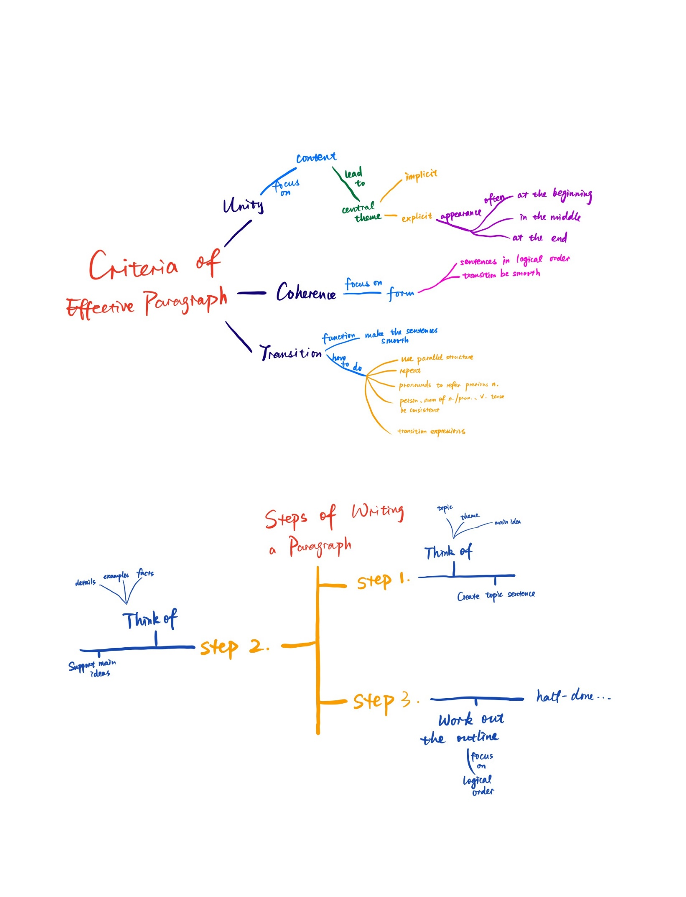

**4, Mind map of “Steps of writing a paragraph”**

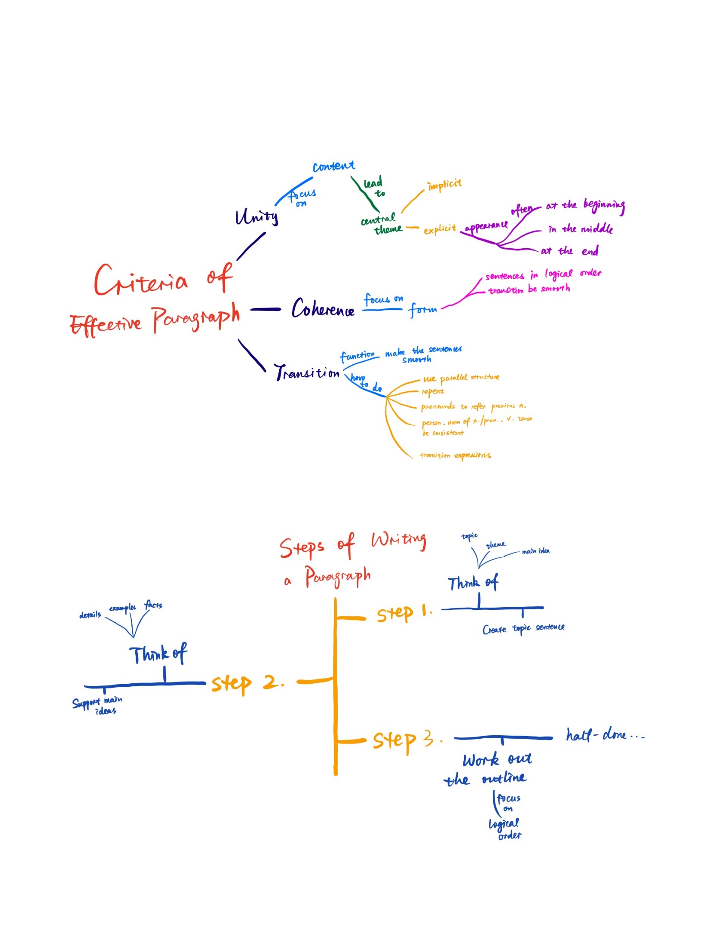

# Task 2: Learning outcomes

Language and writing are tools used to express people's inner world. The ability to use language determines our ability to organize and express our thoughts.

In Task1 I learned about the types of words and sentences and the effectiveness of paragraphs. Different types of words and sentences can have different effects. For example, common words are easy to understand and sound relaxed while formal words are rigorous. Short sentences can express important ideas and facts, while long sentences are good for details. In the future study and work, we often have to express ourselves clearly within limited time or space, such as writing papers, company meeting reports and so on. We need to use different types of words and sentences to emphasize the key points we want to express. We also need to pay attention to the wording and expressions so that the content we express is accurate and there will be no misunderstanding. Sometimes we even need to use appropriate skills to make our words more appealing and move people's hearts. These techniques are inseparable from the dissection of word and sentence types and their corresponding functions. In addition, different occasions are used in different ways of expression. If you use slang in formal meetings, you will be seen as insensitive or even sensationalist. Also you can't use a lot of written language in small talk. Therefore, only by systematically learning writing skills can we properly express whatever we want on various occasions

In fact, I have heard that many Chinese students studying abroad write terrible English papers, whose language, logic, organization of paragraphs are not up to the tutor's standard. On the one hand, this is because they’ve had no or little systematic academic English writing training, on the other hand, it is because of the differences in mother tongue. Chinese is an ideographic language, its expression is more euphemistic and jumping. English is a Latin language, more logical and normative. Although in today's Chinese society, it pays more and more attention to the norms of Chinese language, in the context of globalization, we will be more in line with the West, especially those of science majors We will write many professional English papers. Learning English writing skills has a profound influence on revising our Chinese thinking, standardizing expressions and many other aspects.